|  |
| --- |
| SAS® Marketing Operations Management  SAS® MOM 6.5 A3G002 |

SAS®

The correct bibliographic citation for this manual is as follows: SAS Institute Inc. 2018. *SAS:* SAS*® MOM 6.5 A3G002***.** Cary, NC: SAS Institute Inc.

**SAS® MOM 6.5 A3G002**

Copyright © 2018, SAS Institute Inc., Cary, NC, USA

All rights reserved. Produced in the United States of America.

**U.S. Government Restricted Rights Notice:** Use, duplication, or disclosure of this software and related documentation by the U.S. government is subject to the Agreement with SAS Institute and the restrictions set forth in FAR 52.227-19, Commercial Computer Software-Restricted Rights (June 1987).

SAS Institute Inc., SAS Campus Drive, Cary, North Carolina 27513.

March, 2018

SAS® Publishing provides a complete selection of books and electronic products to help customers use SAS software to its fullest potential. For more information about our e-books, e-learning products, CDs, and hard-copy books, visit the SAS Publishing Web site at **support.sas.com/pubs** or call 1-800-727-3228.

SAS® and all other SAS Institute Inc. product or service names are registered trademarks or trademarks of SAS Institute Inc. in the USA and other countries. ® indicates USA registration.

Other brand and product names are registered trademarks or trademarks of their respective companies.

Contents

Preface 4

Purpose 4

Who Should Read This Document 4

Need for this Hot Fix 4

1 SAS® Marketing Operations Management 6.5 A3G002 5

1.1 Pre-requisites 5

1.2 Install A3G002 for 6.5 6

1.3 Post Installation Steps 8

2 Appendix 9

2.1 Issues Addressed 9

Preface

Purpose

This document has the instructions for applying A3G002 on a SAS Marketing Operations Management 6.5 installation.

Who Should Read This Document

This document should be read by the person applying A3G002.

Need for this Hot Fix

A3G002 contains all the defect fixes prioritized by Technical Support that were reported by customers recently. Details later in this document.

# SAS® Marketing Operations Management 6.5 A3G002



## Pre-requisites

***Note:***

* **SAS *Marketing Operations Management 6.5 should be installed before applying this hot fix.***

**(*The hot fix ID for 6.5_R1 hot fix 2 is A3G002)***

* ***To verify the MOM hot fix currently installed, navigate to the login page and click the “About” link at top right side of the screen. The hot fix version displayed correlates to the following:***
* ***6.5_R1 indicates that no hot fixes are currently applied***
* ***6.5_R1 Hotfix A3G001 is same as 6.5_R1 Hotfix 1***
* ***6.5_R1 Hotfix A3G002 is same as 6.5_R1 Hotfix 2***
* **If you use the manual mode of database script execution, then before applying the hot fix ensure you have run the script or scripts available at the following locations:**

***a.      For 6.5 (without any MOM 6.5 hot fixes applied) to 6.5 A3G002, run the following scripts in the same order. The second script (if listed) should be executed only after the successful execution of the first script.***

1. ***Unzip “SAS MOM 6.5 A3G002.zip” file to a folder and go to the Deployment folder inside the unzipped location.***
2. ***Unzip “65_R1_U0_HF0_To_65_R1_U0_HF1 Migration.zip” to get the Migration Schema Creation database script. Run the SQL code only on the tenant database before you select the manual execution mode.***
3. ***Unzip “65_R1_U0_HF1_To_65_R1_U0_HF2 Migration.zip” to get the Migration Schema Creation database script. Run the SQL code only on the tenant database before you select the manual execution mode.***

***b.      For 6.5 (with MOM hot fix A3G001 applied) to 6.5 A3G002, run the following scripts in the same order. The second script (if listed) should be executed only after the successful execution of the first script.***

1. ***Unzip “SAS MOM 6.5 A3G002.zip” file to a folder and go to the Deployment folder inside the unzipped location.***
2. ***Unzip “65_R1_U0_HF1_To_65_R1_U0_HF2 Migration.zip” to get the Migration Schema Creation database script. Run the SQL code only on the tenant database before you select the manual execution mode.***
3. A3G002 is released for SAS Marketing Operations Management 6.5. You should install this version on the servers.
4. If there is any customization, *you are required to merge the custom code with the hot fix code base after applying this hot fix*.
5. If there is any integration between SAS Marketing Operations Management solution and any other SAS Customer Intelligence solutions, refer to the appropriate deployment guides. (Please contact SAS Technical Support if you have questions about the deployment guides.)
6. The web services machine should be available and the IIS on this machine should be started. (This is used by the hot fix installer). Log on to the current SAS Marketing Operations Management setup through the browser to check.
7. The A3G002 for SAS Marketing Operations Management 6.5 should be installed on all the servers in the setup in the following sequence:
   1. ***Application server***
   2. ***Solutions server***
   3. ***Cataloger server and Media server***
   4. ***All other servers***

## Install A3G002 for 6.5

The following is updated by the hot fix installer:

* NTFS for all the tenants.
* Database for all the tenants created on the SAS Marketing Operations Management 6.5 installation.

Steps to Install A3G002:

1. To install A3G002, unzip ***SAS MOM 6.5 A3G002.zip*** file to a folder.
2. Go to the ***Deployment*** folder inside the unzipped location.
3. Double click ‘Setup.exe’ and select the ‘Install HotFix’ option. **(Figure 1)**

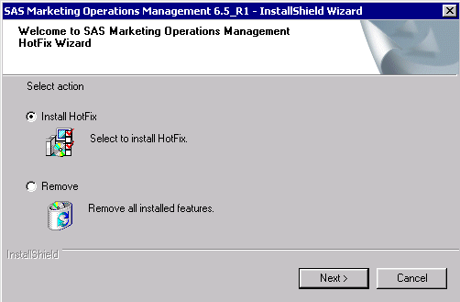

1. Select ‘Automatic’ for the database execution mode. If you wish to select Manual mode, ensure you have followed the pre-requisite steps in Section 1.1 of this document.

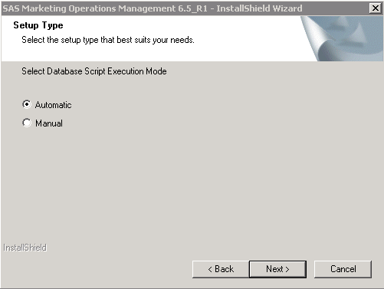

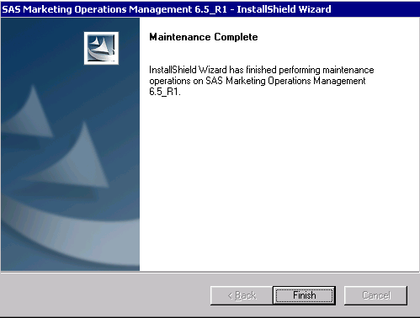

Figure No. 3

1. Be sure to restart the machine after installation.

## Post Installation Steps

1. If a new tenant is created after the installation of A3G002, reset the IIS.
2. Restart all the Windows Services for SAS Marketing Operations Management after installation is complete.
3. Any custom code, if present, is replaced by the standard code after installation. *Replace the standard code with the custom code created in the pre-requisite section*.

# Appendix

## Issues Addressed

|  |  |  |
| --- | --- | --- |
| **Sr. No.** | **SAS Notes** | **Description** |
| **1.** | [SN-060969](http://support.sas.com/kb/60/969.html) | You receive errors when you move an activity in SAS® Marketing Operations Management |
| **2.** | [SN-060889](http://support.sas.com/kb/60/889.html) | The Recovery Sheet report in SAS® Marketing Operations Management 6.5 might show incorrect data or no data at all |
| **3.** | [SN-060890](http://support.sas.com/kb/60/890.html) | The Contributor Information report might show an incorrect number of delayed tasks in SAS® Marketing Operations Management |
| **4.** | [SN-061282](http://support.sas.com/kb/61/282.html) | The approval file is missing in SAS® Marketing Operations Management |
| **5.** | [SN-061265](http://support.sas.com/kb/61/265.html) | The deliverable manager does not receive the Task Completion notification email in SAS® Marketing Operations Management |
| **6.** | [SN-059585](http://support.sas.com/kb/59/585.html) | Replies to comments are missing in a downloaded approval file in SAS® Marketing Operations Management |
| **7.** | [SN-061112](http://support.sas.com/kb/61/112.html) | MP4 video file support in Media Annotations in SAS® Marketing Operations Management 6.5 |
| **8.** | [SN-058470](http://support.sas.com/kb/58/470.html) | The server returns an HTTP 200 response code when logon credentials are sent to the SAS® Marketing Operations Management website |
| **9.** | [SN-060188](http://support.sas.com/kb/60/188.html) | Formatting Issues in Strategic Planner Reports (Budgets Summary & Invoice Reconciliation Reports) in SAS® Marketing Operations Management |
| **10.** | [SN-059812](http://support.sas.com/kb/59/812.html) | Facet series records are not displayed when you edit activity type on the activity page of Strategic Planner in SAS® Marketing Operations Management |
| **11.** | [SN-060014](http://support.sas.com/kb/60/014.html) | Offer folders are expanded and contain plus signs erroneously in SAS® Marketing Operations Management |
| **12.** | [SN-059902](http://support.sas.com/kb/59/902.html) | Preceding offer folders do not expand in SAS® Marketing Operations Management |
| **13.** | [SN-059808](http://support.sas.com/kb/59/808.html) | Offer folders do not expand in SAS® Marketing Operations Management |
| **14.** | [SN-059451](http://support.sas.com/kb/59/451.html) | A performance delay occurs in the Offer Management module in SAS® Marketing Operations Management |
| **15.** | [SN-059589](http://support.sas.com/kb/59/589.html) | SAS® Marketing Operations Management does not send the correct radio-button value to the Brief Custom Details page in SAS® Marketing Automation |
| **16.** | [SN-060549](http://support.sas.com/kb/60/549.html) | You receive an error when you run the Marketing Process Efficiency Analysis report in SAS® Marketing Operations Management |
| **17.** | [SN-058443](http://support.sas.com/kb/58/443.html) | The Activity Budget and Spends Report in SAS® Marketing Operations Management fails and returns an error |
| **18.** | [SN-059588](http://support.sas.com/kb/59/588.html) | The thumbnail is missing for an MP3 file in a Digital Library dashboard channel in SAS® Marketing Operations Management |
| **19.** | [SN-058590](http://support.sas.com/kb/58/590.html) | You see an X instead of an asset's thumbnail image in the Digital Library module of SAS® Marketing Operations Management |
| **20.** | [SN-058511](http://support.sas.com/kb/58/511.html) | Asset counts do not show properly in SAS® Marketing Operations Management |
| **21.** | [SN-061999](http://support.sas.com/kb/61/999.html) | The Active and OnHold counts are not correct in the Contributor Information report in SAS® Marketing Operations Management |
| **22.** | [SN-062001](http://support.sas.com/kb/62/001.html) | Support is available for Microsoft Office 2016 in SAS® Marketing Operations Management via hot fix A3G002 |
| **23.** | [SN-062002](http://support.sas.com/kb/62/002.html) | The Microsoft Excel Calendar export is not saved in SAS® Marketing Operations Management |